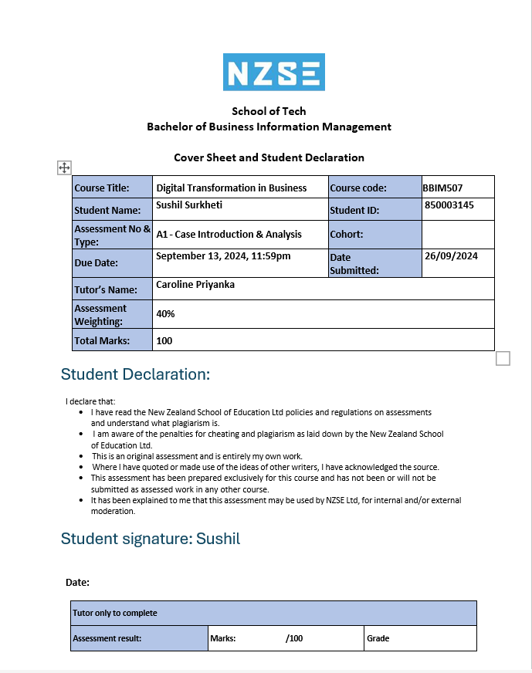

Table of Contents

Task 1: Digital Transformation in Business 3

Task 1.a: 3

Task 1.b: 7

Task 1.c: 8

Task 1.d: 9

Task 1.e: 10

Task 1.f: 11

References 13

# Task 1: Digital Transformation in Business

## Task 1.a:

**Explanation of Digital Services:** A service is deemed digital if it is delivered, accessed, or utilized digitally. They work on a range of tasks, from simple ones like answering emails to more complex ones like operating self-driving cars or doing remote surgery. These services usually cover the use of mobile devices, the internet, and other digital platforms. (mactivittie, 2024)

**Key characteristics of digital services:**

**Accessibility:** Digital services may be accessed from any location as long as there is internet connectivity. For example, cloud-based programs such as Google Docs enable remote collaboration on documents from any place.

**Efficiency:** They improve procedures by using less time and resources. For instance, online banking allows users to manage their accounts without physically visiting a bank, which reduces lineups and paperwork.

**Personalization:** Web applications are designed to adapt to the preferences of their users. The way Netflix and other services suggest TV shows and movies to users based on what they have already watched is a great example.

**Innovation:** Digital services frequently include cutting-edge technologies like blockchain, artificial intelligence (AI), and the Internet of Things (IoT) to enhance functionality. Virtual assistants like Alexa, for example, employ AI to help people manage their daily duties. (mactivittie, 2024)

**Model Diagram of Digital Services**

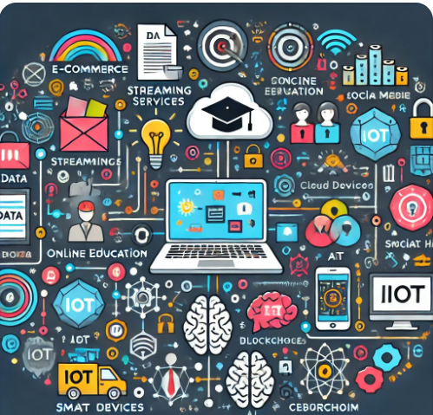 (author, 2024)

**Key components of the diagram:**

The figure shows how several components work together to provide digital services. Each part has a specific purpose in the wider digital environment. The following is a list of the necessary elements:  
  
**E-commerce:** The buying and selling of goods and services through online markets like Amazon and eBay. These services have revolutionized traditional shopping by allowing businesses to operate online and reach a global customer base.

**Streaming Services:** Without being constrained by conventional TV schedules, consumers may watch and listen to material on websites like Netflix and Spotify whenever they want.   
  
**Online education:** Courses and materials are made available to individuals all over the world through platforms like Coursera and Khan Academy.   
  
**Social media:** Connecting individuals through platforms like Facebook and Instagram, these websites enable worldwide communication and content sharing, revolutionizing personal and professional relationships.   
  
**Cloud computing:** Services like Google Cloud and Amazon Web Services (AWS) provide on-demand access to storage and processing capacity via the internet by doing away with the need for physical hardware.

**IoT:** The Internet of Things, or IoT, allows smart equipment to communicate with one another and perform various tasks automatically. Examples of these items include smart refrigerators and fitness trackers.

**AI:** The phrase artificial intelligence, or AI, refers to computer programs designed to do tasks that typically require human intelligence, such language understanding and decision-making.

Blockchain: A secure, decentralized digital ledger that logs transactions and saves data; it is widely acknowledged for having enabled the creation of cryptocurrencies such as Bitcoin.

Cybersecurity: Protects digital infrastructure and data against unauthorized access and hacking, protecting corporate assets and user privacy. (author, 2024)

**Interconnections:**

Data: The operation of digital services depends on data. Social media businesses, for example, collect data on user behaviour to customize ads and content, making each user's experience more relevant.   
  
**Networks:** Digital services require the use of mobile and internet networks. Smooth streaming, rapid data transfers, and efficient cloud computing are made possible by 5G and other high-speed connections.   
  
**Devices:** Computers, tablets, and smartphones are just a few of the devices that users may use to interact with these services and access them.   
  
**Platforms:** Operating systems like web browsers, iOS, and Android offer the framework for the features and user interfaces of services. (author, 2024)

## Task 1.b:

**Analysing the Digital Revolution**

"Digital disruption" refers to the rapid shift that digital technology has brought about in several industries. This phenomenon may pose challenges for traditional corporate structures, necessitating a shift to a digital-first approach. The following enumerates the contributing elements to this disruption: (wannemacher, 2024)

**Sources of Digital Disruption**

**Technological Progress:** Technological Advancement: Businesses must adjust as a result of advances in cloud computing, IoT, and AI. For example, AI chatbots are increasingly taking the place of human customer service professionals in customer care settings since they are a more economical and efficient alternative.   
  
**Changing Consumer Expectations:** The Changing Expectations of Consumers Customers of today want personalized, expedient, and straightforward service. Digital technology is being used by businesses to provide rapid, personalized experiences, such purchase recommendations that are tailored specifically for each user on e-commerce platforms.

**Global Connectivity:** New technology may spread quickly across national borders due to the interconnectedness of the world's marketplaces. This can help businesses develop internationally and reach new customers through digital platforms.

**Regulation:** Changes to the legislation have the potential to help or impede the advancement of digital technologies, particularly in the areas of data protection and artificial intelligence (AI). Companies are compelled to reevaluate how they handle client data by regulations like the GDPR. (webb, 2020)

**Positive Impacts of Digital Disruption**

**Enhanced Efficiency:** Using digital technology to automate activities may save expenses and increase efficiency. For example, factories may run more quickly and reliably when they use robots to do monotonous jobs.  
  
**Better Customer Experiences:** Personalized and expedited encounters are provided by digital services. Websites may provide purchase recommendations based on your past browsing activity, and chatbots with artificial intelligence can offer immediate assistance.  
  
**Innovation and Economic Growth:** Innovation and the emergence of new enterprises are stimulated by disruption, and this results in economic growth. For example, applications like as Uber have transformed the transportation sector and generated new employment prospects.  
  
**Advantages for the Environment and Society:** Digital technology can assist in resolving important issues. For instance, smart energy systems can lower energy usage, while remote healthcare, or telemedicine, improves access to medical treatments in underprivileged areas.(chang, 2023)

**Negative Impacts of Digital Disruption**

**Job Losses:** Automation may result in the elimination of some jobs, especially in manufacturing and other sectors where humans may no longer be needed to do specific tasks.   
  
**Data breaches:** As more personal data is gathered by digital firms, worries over data security and privacy are intensifying. Data breaches provide a significant risk to companies that keep sensitive consumer information.   
  
**Digital Divide:** Individuals differ in their access to digital technology. Inequality would result from inhabitants in remote or poor areas finding it difficult to utilize digital services.   
  
**Industry Disruption:** Some industries may become out of date as digital alternatives multiply. For example, traditional retail outlets have been significantly impacted by the advent of e-commerce.   
  
**Ethical Issues:** Using cutting-edge technologies like artificial intelligence brings up ethical issues. Businesses must, for example, consider the volume of user data they collect and ensure that it is not exploited. (chang, 2023)

## Task 1.c:

**Explanation of Digital Strategy**

A digital strategy is a thorough plan that companies develop to leverage digital platforms, resources, and technology to accomplish their objectives, streamline processes, and improve customer satisfaction. It entails fully integrating digital technology into a business's operations, transforming it into something that benefits clients and creates value. A well-crafted digital strategy integrates seamlessly with the entire company plan by taking into account a wide range of aspects, including consumer behaviour, market trends, competitive positioning, and technology improvements. (domont, 2023)

**Key Components of a Digital Strategy**

A business's digital strategy describes how it intends to use digital technology into its marketing, customer relations, and operations. Its main objective is to match digital activities with corporate objectives, such as raising sales, boosting productivity, and raising client happiness. Well-defined goals, identified target audiences, technology used, digital channel optimization, and ongoing plan review and improvement based on data-driven insights are all necessary components of a successful digital strategy. (emily carter, 2024)

**Example Scenario of a Digital Strategy for a Retail Business**

Giving a retail business an omnichannel presence, for example, might be part of a digital strategy to enable customers to easily make purchases both in-store and online. Chatbots driven by artificial intelligence (AI) might be used by the company to improve customer service, customize marketing campaigns, and use social media for focused advertising. The business could also use analytics to track consumer behaviour and preferences in order to improve its product offers and promotions. Enhancing consumer relationship, increasing revenue, and offering a more fluid and effective shopping experience across digital and physical channels are the objectives of this digital strategy. (brown, 2024)

## Task 1.d:

**The Importance of Digital Transformation**

Digital transformation is crucial for modern businesses because it significantly changes how they operate, improving efficiency, customer experience, and competitiveness. By adopting digital tools and processes, companies can streamline their operations, cut costs, and make better decisions based on data. This transformation helps businesses quickly respond to market changes, offer personalized services, and ensure consistent experiences across different channels, ultimately delivering more value to their customers. (dauherteg, 2024)

**Contribution of Digital Transformation to Marketing Effectiveness:**

In marketing, digital transformation is key to improving effectiveness. It enables businesses to use data analytics and automation to create targeted, personalized marketing campaigns that connect with specific customer groups. The ability to engage in omnichannel marketing ensures that messaging is consistent and appealing across various platforms, which strengthens customer loyalty. Additionally, real-time analytics allow marketers to track how campaigns are performing and make quick adjustments, leading to better results and higher returns on investment. The cost savings and new ways to engage customers that digital transformation offers also make marketing efforts more efficient and successful. (mohamad, 2020)

## Task 1.e:

**Starbucks: Company Overview and Digital Technology Experiences**

I am choosing the Starbucks company as we discussed in the class. Starbucks is a major coffee chain that began in Seattle in 1971. It is well-known for its high-quality coffee, teas, and snacks, and is famous for its cozy café atmosphere. With thousands of stores around the world, Starbucks has become one of the largest coffee brands globally. The company focuses on providing a great coffee experience and creating a welcoming place for people to relax and meet. Starbucks is also committed to sourcing its coffee beans responsibly and supporting sustainability and community efforts. (starbucks, 2024)

**Positive Experiences**

Starbucks has made good use of its mobile app, which allows customers to order and pay ahead, earn rewards, and avoid waiting in line. This has made things more convenient for customers and increased sales. The rewards program in the app encourages customers to come back more often and engage more with the brand. The app also offers personalized features that improve the customer experience. (starbucks, 2024)

**Negative Experiences**

Starbucks has faced some issues with the app, such as performance problems during busy times, which can lead to delays and frustration. The focus on digital orders has sometimes affected the in-store experience, with some customers feeling that personal service is lacking. There are also concerns about privacy because the app collects a lot of customer data. Starbucks is working on fixing these problems by improving app performance, protecting customer data, and ensuring that the digital experience enhances rather than replaces the in-store experience. (starbucks, 2024)

## Task 1.f:

**Recommendations for Improvements in Digital Transformation**

**1. Improve App Performance and Reliability**

**Recommendation:** Starbucks should focus on enhancing the performance and reliability of its mobile app, especially during busy periods. This means investing in better technology and infrastructure to handle high traffic volumes more effectively. Key areas for improvement include upgrading server capacity, optimizing the app’s code, and using load-balancing techniques.

**Rationale:** If the app experiences slowdowns or crashes during peak times, it can frustrate customers and hurt their overall experience. A fast and reliable app is essential for keeping customers satisfied and encouraging them to return. By solving these performance issues, Starbucks can provide a smoother and more efficient service, helping to retain customers who might otherwise be discouraged by technical problems.

**Implementation Steps:** To enhance app performance, Starbucks should first conduct a detailed audit to find areas that need improvement. The company should then invest in scalable cloud services or upgrade existing servers to manage higher traffic. Optimizing the app’s code will improve its speed and efficiency. Performance monitoring tools should be implemented to quickly identify and fix any issues. Finally, extensive testing should be done to ensure the app performs well even during peak times. (hasselbach, 2023)

**2. Improve Data Privacy and Security Measures**

**Recommendation:** Starbucks should strengthen its data privacy and security measures to better protect customer information collected through its mobile app. This includes using advanced encryption for data storage and transmission, improving how user consent is obtained, and regularly auditing security practices.

**Rationale:** With growing concerns about data privacy, customers are more worried about how their personal information is handled. By improving data protection practices, Starbucks can comply with regulations and build trust with customers. Ensuring data is securely managed can prevent breaches, protect customer privacy, and increase customer loyalty.

**Implementation Steps:** To boost data privacy and security, Starbucks should review and update its data protection policies to meet current standards and regulations. Implementing strong encryption methods for both data storage and transmission is crucial. The company should also make the consent process clearer by informing customers about how their data will be used and getting explicit approval. Regular security audits and vulnerability checks should be carried out to find and address potential risks, ensuring that data protection measures remain effective and current. These steps will help Starbucks enhance its digital security and reassure customers that their information is safe. (dataprivacymanager., 2024)

# References

The Power of Personalization: Customization Trends in Fashion E-commerce. (n.d.). Indian Retailer. https://www.indianretailer.com/article/retail-business/fashion-accessories/power-personalization-customization-trends-fashion-e

‌ Brown, R. (2019, April 24). The Meaning of Digital Transformation in the Retail Industry: Examples, Benefits & Trends. Ionic.io; Ionic. https://ionic.io/resources/articles/the-meaning-of-digital-transformation-for-retail#h-intro-to-digital-transformation-in-retail-industry/

‌ Chang, C.-W., & Chang, S.-H. (2023). The Impact of Digital Disruption: Influences of Digital Media and Social Networks on Forming Digital Natives’ Attitude. SAGE Open, 13(3). https://doi.org/10.1177/21582440231191741

‌ *DPM. (2021, September 28). 8 Ways To Improve Data Security and Data Compliance. Data Privacy Manager. https://dataprivacymanager.net/8-ways-to-improve-data-security-and-data-compliance/*

*‌* Accenture. (2022). Digital transformation. Accenture.com. https://www.accenture.com/us-en/insights/digital-transformation-index

‌ Digital Transformation and IT Strategy Toolkit. (2024). Domont Consulting. https://www.domontconsulting.com/products/digital-transformation-toolkit?variant=32127821316178&msclkid=407f954c14ce111bff06f39a2655fec5&utm_source=bing&utm_medium=cpc&utm_campaign=2.%20Top%20Profitable%20KWs&utm_term=digital%20strategy%20and%20digital%20

‌ Carter, E. (2019, July 22). Digital Marketing Components: 7 Elements of Successful Digital Strategies. WebFX Blog. https://www.webfx.com/blog/marketing/digital-marketing-components-5-elements-of-a-successful-digital-marketing-strategy/

‌ How to improve IT application performance and reliability. (n.d.). Flexential. https://www.flexential.com/resources/blog/how-improve-it-application-performance-and-reliability

‌ What is a Digital Service? (n.d.). Www.f5.com. https://www.f5.com/company/blog/what-is-a-digital-service

‌ Hien, N. N., & Nhu, T. N. H. (2022). The effect of digital marketing transformation trends on consumers’ purchase intention in B2B businesses: The moderating role of brand awareness. Cogent Business & Management, 9(1). Tandfonline. https://doi.org/10.1080/23311975.2022.2105285

‌ Starbucks: The Best Coffee Makers and Cold Brew Coffee. (n.d.). Starbucks Coffee Company. https://www.starbucks.co.nz/

‌ Digital Leaders. (n.d.). Forrester. https://www.forrester.com/digital-business/

‌ Webb, A. (2020). The 11 Sources of Disruption Every Company Must Monitor. MIT Sloan Management Review. https://sloanreview.mit.edu/article/the-11-sources-of-disruption-every-company-must-monitor/

‌